|  |
| --- |
| 1. ***Mini Project Synopsis on***   **Attendance Management System**  **S.E. – Computer Science and Engineering-Data Science**  **Submitted By**  **Krishna Gupta 21107024**  **Meris Gada 21107041**  **Himanshu Maurya 21107038**  **Tushar Goud 21107024**    **Under The Guidance Of**  **Ms. Poonam Pangarkar**        **DEPARTMENT OF CSE-DATA SCIENCE**  A.P. SHAH INSTITUTE OF TECHNOLOGY  G.B. Road, Kasarvadavali, Thane (W), Mumbai-400615  UNIVERSITY OF MUMBAI    **Academic year: 2022-23** |
| **CERTIFICATE**        This is to certify that the Mini Project report on **Attendance Management System** has been submitted by Krishna Gupta(21107024), Himanshu Maurya(21107038), Meris Gada(21107041), and Tushar Goud(21107027) who are Bonafede students of A. P. Shah Institute of Technology, Thane, Mumbai, as a partial fulfillment of the requirement for the degree in **Computer Science and Engineering(Data Science)**, during the academic year **2022-2023** in a satisfactory manner as per the curriculum laid down by the University of Mumbai.      Ms. Poonam Pangarkar  Guide      Prof. Anagha Aher Dr. Uttam D. Kolekar  Head Department of CSE-Data Science Principal    External Examiner(s)  1.  2.    Place: A. P. Shah Institute of Technology, Thane  Date: |
| **TABLE OF CONTENTS**    1. Introduction...........................................................................................................1 1.1. Purpose.........................................................................................................1 1.2. Objectives....................................................................................................1  1.3. Scope...........................................................................................................2  2. Problem Definition……………………...............................................................3  3. Proposed System…………..................................................................................4  3.1. Features and Functionality………………………………………………..4  4. Project Outcomes….............................................................................................5  5. Software Requirements …..................................................................................11  6. Project Design….................................................................................................12  7. Project Scheduling…...........................................................................................13  8. Conclusion...........................................................................................................14  9. References……………………………………………………………………...15  10. Acknowledgement…………………………………………………………….16 |

**Chapter 1**

**Introduction**

The process of monitoring attendance in any institute is an important part of determining the efficiency of the services offered by the institution and the general and those who benefit from the institution’s services, in our case, the students. This process is a painstaking routine, and as such, this system proposes a new way of dealing with the old system.

The attendance management system is software developed to mark the daily attendance of students in schools and colleges. It keeps the record of the student’s attendance in MySQL from the data provided by the teacher (i.e., present or absent).

The attendance management system is only applicable to teachers, staff members, and any other faculty. This project helps to overcome both time-consuming and prone errors.

**1.1.Purpose :**

The old attendance management system requires a lot of paperwork to overcome this problem we have built this software. Teachers, employers, and any other faculty mark attendance by calling out names but by using this software there is no need for such a thing. As nowadays fake attendance, and proxies have been common issues; this project eliminates such issues.

Attendance management minimizes the time required for the attendance marking system. To store the attendance statistics of any individual for a long time.

**1.2.Objectives :**

To build a user-friendly attendance management desktop application for teachers. To overcome the problems faced in an old attendance management system.

Making no use of any type of document for storing data and eliminating the use of paper. To make marking attendance easy, effortless and convenient. Making attendance management system error-free and storing data more accurately. Attendance books traditionally are big grids with tiny squares that are hard to read and can be easy to make errors in.

**1.3.Scope :**

It can be used in schools, colleges, offices, etc. It can be useful for teachers, principle, and higher authorities in offices and commercial places. The proposed system will manage the attendance process that will be saved in a specific database.

**Chapter 2**

**Problem Definition**

Attendance Management System is a software developed for daily student attendance in schools, colleges, and institutes. It facilitates to access the attendance information of a particular student in a particular class. It facilitates access to a particular student's attendance in a particular class. No chances of fake attendance or proxies. Save students’ time as well as teachers’ time. This system will also help in evaluating the attendance eligibility criteria of a student. With just a click on the mouse, the system will be able to produce the students' attendance report thus reducing the need for manual labor which is prone to human errors and time-consuming.

**Chapter 3**

**Proposed System**

The attendance management system is software developed to mark the daily attendance of students in schools and colleges. It keeps the record of the student’s attendance in MySQL from the data provided by the teacher (i.e., present or absent). This also helps in the easy calculation of the monthly attendance of each student. This will reduce the use of paper as all the data is computerized. This will also reduce false attendance marked by one student for another student. There are also many disadvantages of the manual attendance system.

**3.1.Features & Functionality :**

1. AMS also can be used on low specs computer.

* It is not compulsory that the user must have high end Laptops or PC’s.

1. Managing attendance is efficient in real-time.

* This allows teacher with proper management & provides with instant result.

1. It reduces errors.

* It reduces the errors of calculation of attendance.

1. Manages regular attendance and stores the details of individual students.

* It gives the regular attendance of students & shows the previous record of the student.

1. Evaluation of attendance eligibility criteria of Students.

* It calculates the total attendance percentage of the student of a month.

**Chapter 4:**

**Project Outcomes**

Here, if a user already has an account, then the user can log in. If a user doesn’t have an account, then the user can create a new account by clicking on the Signup button.

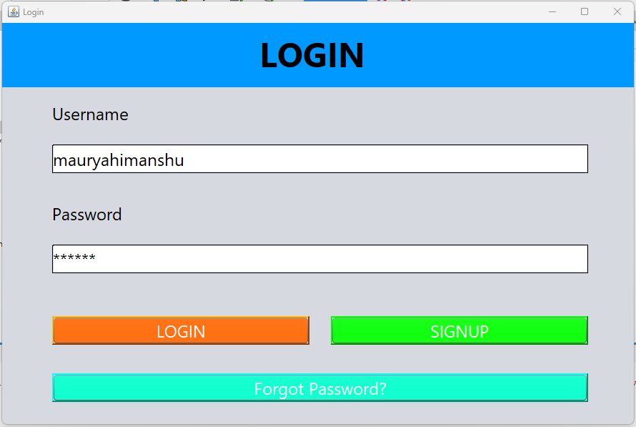

**Figure 6.1: Login page**

Users can create his/her new account by filling in the following details: Username (It should be unique), Name, Password, Security Question, and Answer to the security question.

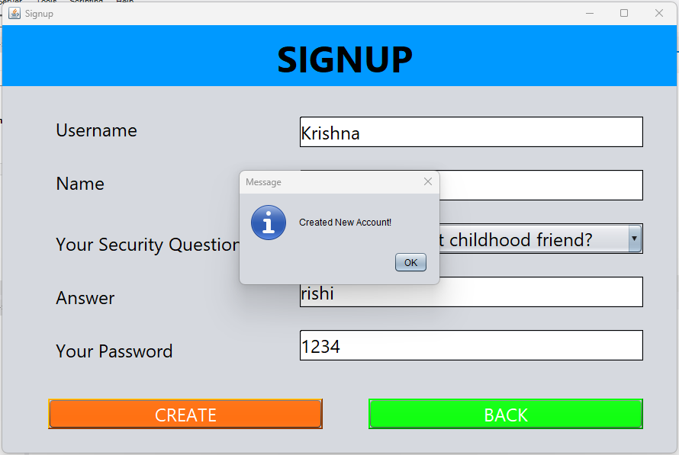

**Figure 6.2: Signup page**

If a user has forgotten his Password, then the user can use Forgot Password button on the login page to retrieve his/her password.

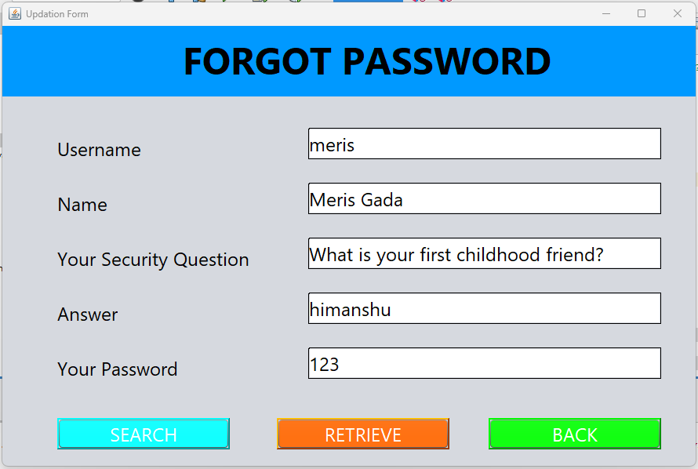

**Figure 6.3: Forgot Password**

Here, the user has been provided with many operations such as adding a new student, viewing the details of the students, marking the attendance, and can delete student data.

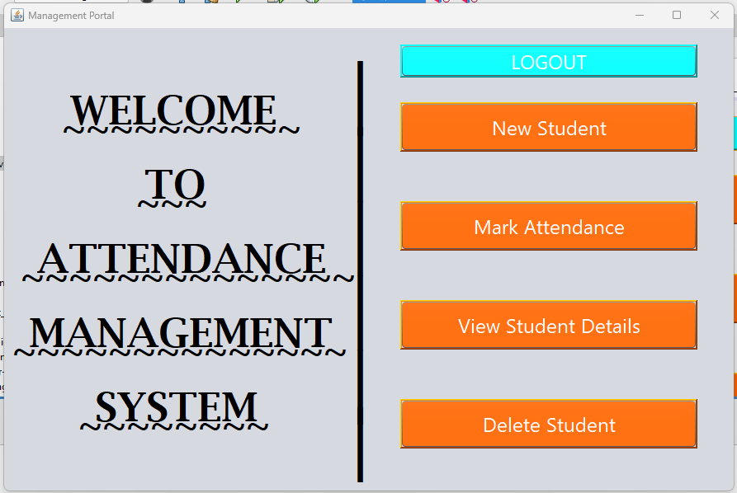

**Figure 6.4: Home Page**

Users can add a new student by filling in the following details: Student ID (It should be unique), Name, Father’s name, and Batch ID.

The Joining date will be automatically filled in by the system i.e., the system’s present date.

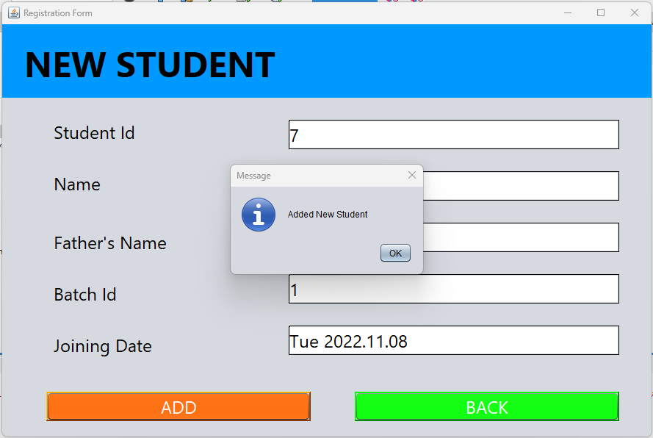

**Figure 6.5: Add a new student**

Here, the user can view the added students and their respective data.

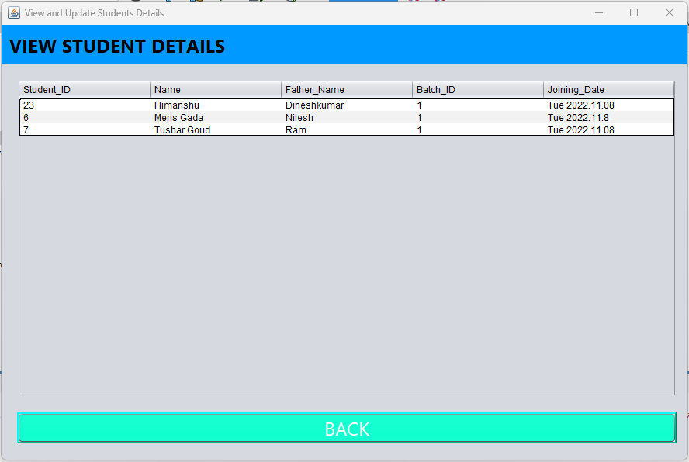

**Figure 6.6: Student Details**

Here, the user can mark the student’s attendance.

By just filling in the student Id and clicking on the search button the student’s name and father’s name will be automatically filled in.

Users can mark the attendance by filling the text fields with ‘P’ or ‘A’ where p stands for present and a stand for absent.

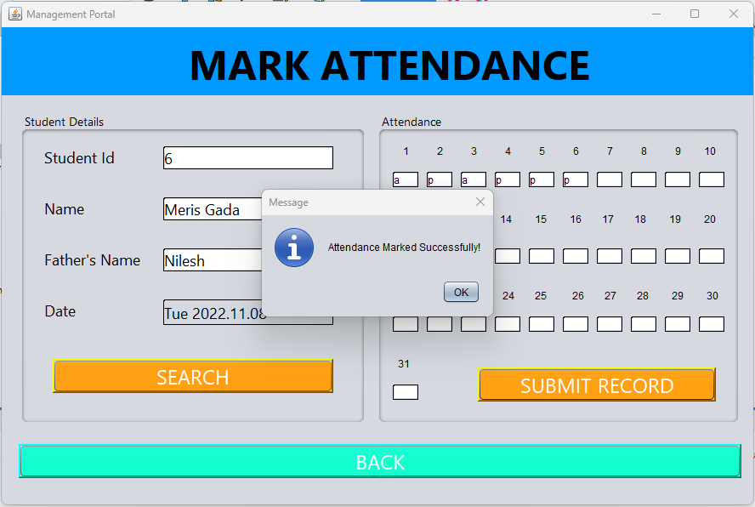

**Figure 6.7: Mark Attendance**

Users can delete an existing student.

By entering the student Id and then clicking on the delete button user can delete the data of the existing student.

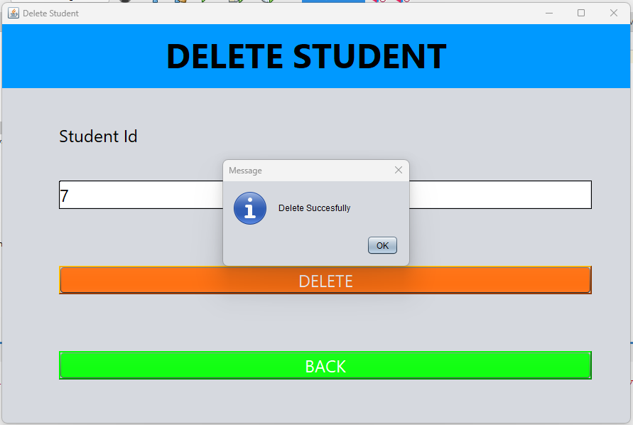

**Figure 6.8: Delete student details**

By clicking on the file menu; a dropdown menu appears and then by clicking on the logout menu, the user can log out.



**Figure 6.9: Logout**

**Chapter 5**

**Software Requirements**

1. JDK:

The Java Development Kit (JDK) is a software development environment that offers a collection of tools and libraries necessary for developing Java-based software applications. User System must at least have JDK 19 installed. Environment variables correctly set. The JDK and the JRE have minimum processor, disk space, and memory requirements for the 64bit Windows platform.

1. Database:

MySQL is relational database management system (RDBMS). The data in a MySQL database are stored in tables that consist of columns and rows. MySQL is a database system that runs on a server. Attendance management system uses MySQL database (version 8).

1. IDE:

NetBeans is an integrated development environment (IDE) for Java. NetBeans allows applications to be developed from a set of modular software components called modules. NetBeans runs on Windows, macOS, Linux, and Solaris. Attendance Management System uses Apache NetBeans IDE (version 15).

**Chapter 6**

**Project Design**

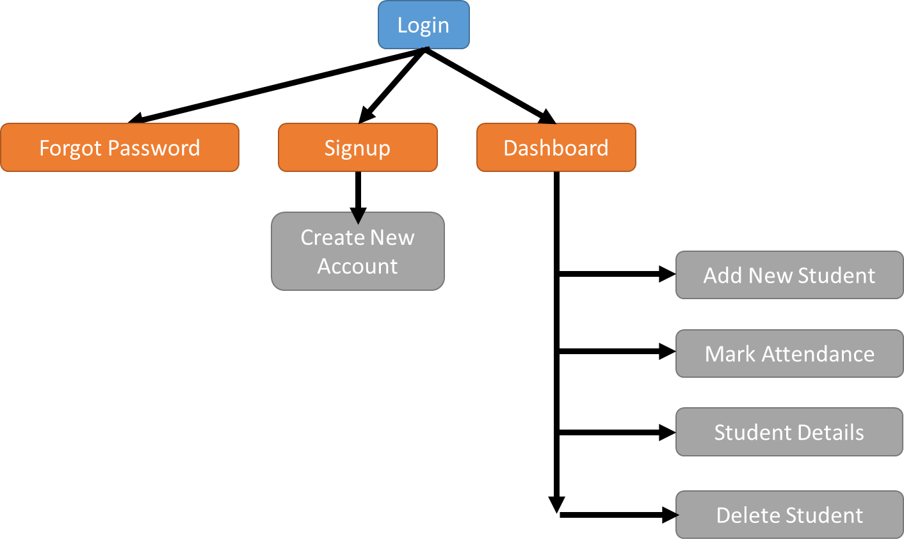

In Attendance management system the user will first the login page, here the user who already have an account they can directly login with their user name and password and user which doesn't have an account can create by signing process. In case user forgotten his password then user can retrieve his password from forgot password page there the user has to enter username to search his detail from database by answering security question user can retrieve his password.

After login process the user will visit dashboard and over there he can perform crud operation (create read update delete), here user can add students. After adding the student the user can view students detail on the student detail page. Now adding students information use can mark student attendance by clicking on mark attendance page, where user can get student detail whose information is already entered by entering student ID and can mark attendance of particular student of a present lecture, for marking attendance user has top fir present and a for absent and attendance get recorded by clicking on submit record button. If user has to remove student from existing data base then he has to enter student ID and click on the delete button to delete the Id of particular student from existing data base. Once the attendance get marked user can logout by clicking on logout button.

**Chapter 7**

**Project Scheduling**

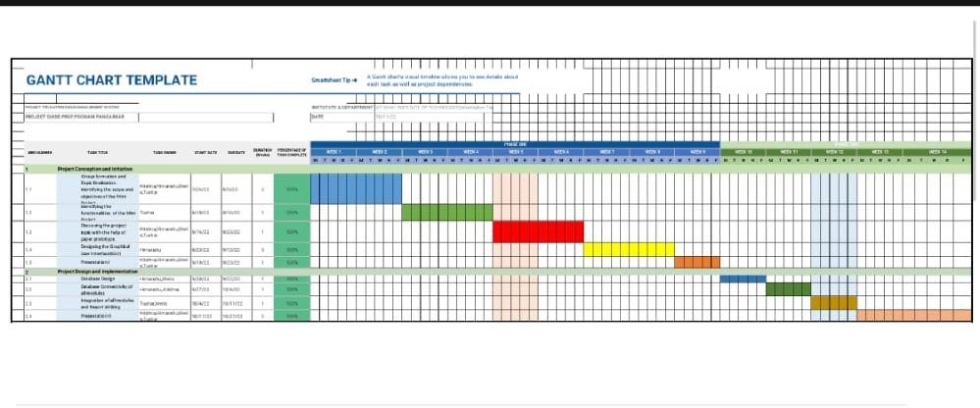

**Chapter 8**

**Conclusion**

Before developing Attendance Management System project, we have analyzed the issues faced by the old attendance system which was paper-based system. We have tried to bring a revolution in the old attendance system by developing a digitalized computer based software. Since, it is digitalized the issue of paperwork, file handling will be replaced by the software. It can perform normal operations of attendance system such as adding a new student, deleting an existing student from the database, marking attendance and storing it in the database.

**Chapter 9**

**Reference**

[1] Tutus Funny, “Tutorial to use basic GUI development in NetBeans and database connectivity”, www.tutussfunny.com.

[2] Shaktiman Singh, “Tutorial about attendance management system GUI”, https://youtube.com/channel/UCfNpwDwXcpCpMJqc4bex0OA.

[3] Amit Techie, “Tutorial to use MySQL workbench”, https://youtube.com/c/Amittechie

|  |
| --- |
| **Acknowledgement**  This project would not have come to fruition without the invaluable help of our guide **Prof. Poonam Pangarkar**. Expressing gratitude towards our HoD, **Prof. Anagha Aher**, and the Department of Computer Science and Engineering-Data Science for providing us with the opportunity as well as the support required to pursue this project. We would also like to thank our teachers Prof. Rajashri Chaudhari and Prof. Vaibhav Yavalkar who gave us their valuable suggestions and ideas when we were in need them. We would also like to thank our peers for their helpful suggestions. |